[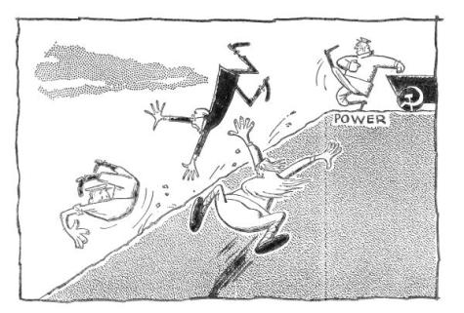](https://scottthong.files.wordpress.com/2008/08/redprimer01.jpg)

**October, 1917**  
Once on top, the Party insisted upon assuming the thankless job of ruling, generously waving aside all help.

This is what they celebrate nowadays as the Great October Revolution.

[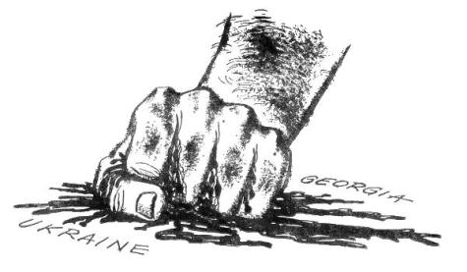](https://scottthong.files.wordpress.com/2008/08/redprimer02.jpg)

The Soviets’ love for their fellow men never recognized borders. The new Ukranian Republic was allowed to join the new Russian Soviet Republics…”voluntarily.”

The independence of the new Georgian Republic was also granted by the Soviets in 1921. To “guarantee” this “independence,” the Soviets incorporated Georgia into the Soviet Union eight months later, after Red Army invasion.

[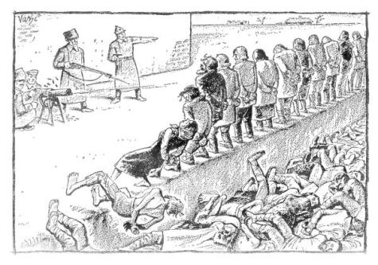](https://scottthong.files.wordpress.com/2008/08/redprimer03.jpg)

Food was scarce, creating some discontent in certain groups who had not found enough calories in Communist theories. The Party had a simple and effective method to create more food per capita.

When the Party finished, there were ten million fewer dissatisfied people.

[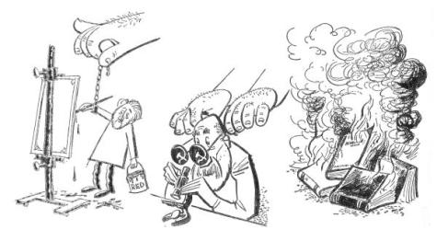](https://scottthong.files.wordpress.com/2008/08/redprimer04.jpg)

[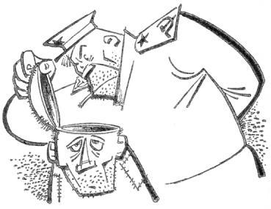](https://scottthong.files.wordpress.com/2008/08/redprimer05a.jpg)

The Party sponsored everything that had been “repressed” by the Czars. Art, science, literature — every aspect of culture — was given a helping hand by the Party, which insisted that every Russian keep an open mind.

[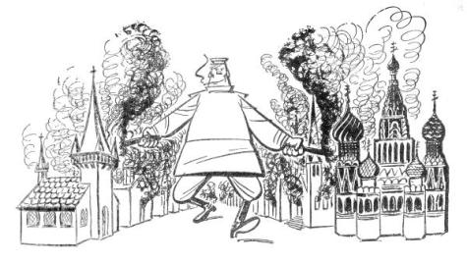](https://scottthong.files.wordpress.com/2008/08/redprimer06.jpg)

Religious freedom was applied equally to every church.

[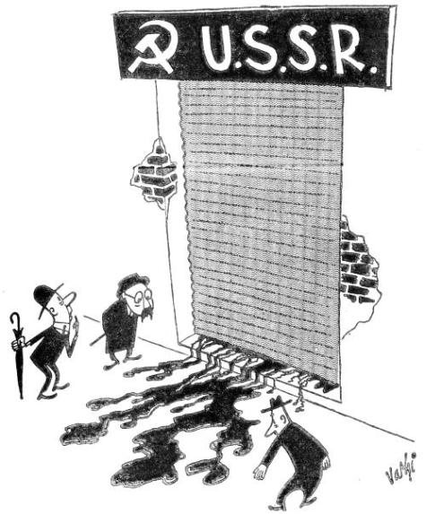](https://scottthong.files.wordpress.com/2008/08/redprimer07.jpg)

The outside world watched, with great interest, the iron curtain of the great shop where the “liberation” of mankind was being fabricated. Occasionally, unmistakable signs of “progress” leaked out.

[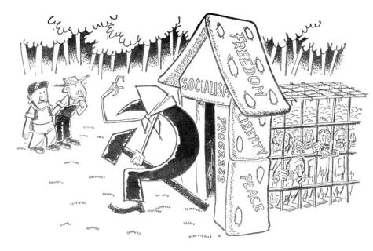](https://scottthong.files.wordpress.com/2008/08/redprimer08.jpg)

Diplomatic acceptance gave the Soviets an opportunity to call for the laborers of the world to unite. The laborers of the Soviet Union, of course, were already united.

[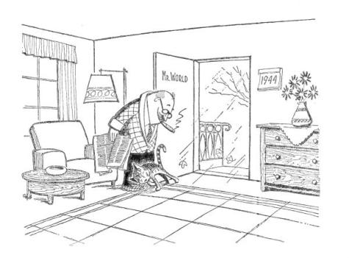](https://scottthong.files.wordpress.com/2008/08/redprimer09.jpg)

[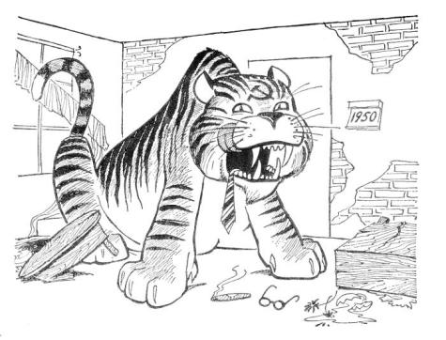](https://scottthong.files.wordpress.com/2008/08/redprimer10.jpg)

By 1950 the world had wondered why it had opened its door to the spirit of the new times.

[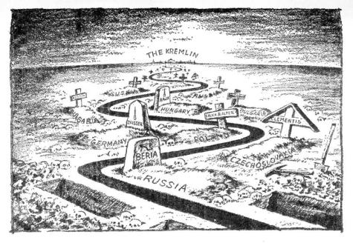](https://scottthong.files.wordpress.com/2008/08/redprimer11.jpg)

For those inside the party, Communism, since its beginning, has followed a straight party line. It only looks crooked from the outside.

[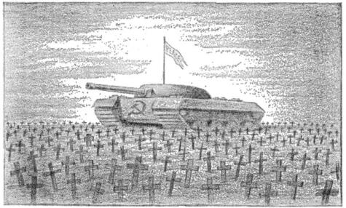](https://scottthong.files.wordpress.com/2008/08/redprimer12a.jpg)

Thanks to the tanks of the glorious Soviet Army, peace was restored in Hungary and all was quiet again on the Eastern Front.

[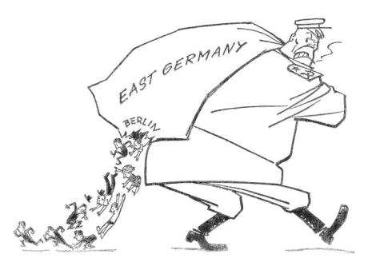](https://scottthong.files.wordpress.com/2008/08/redprimer13.jpg)

East Germany was a full sack, but it had a leak. Day after day thousands were foolish enough to choose the West in preference to Communist Paradise.

[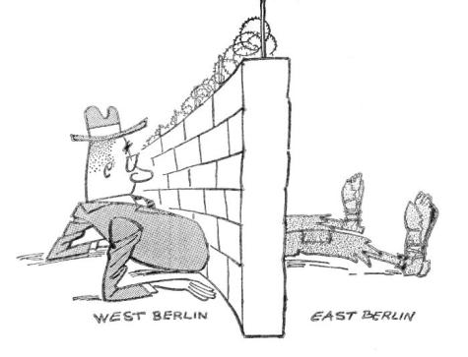](https://scottthong.files.wordpress.com/2008/08/redprimer14.jpg)

**1961**   
So one morning the Wall was there, built, of course, to prevent people from the West from entering the Communist Paradise without permission.

[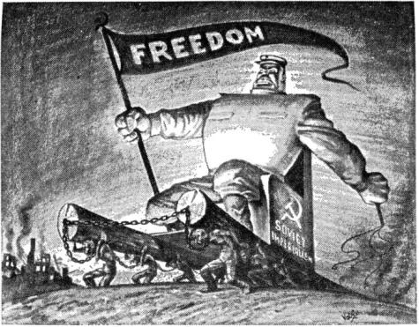](https://scottthong.files.wordpress.com/2008/08/redprimer15.jpg)

The Soviets rode high as the standard bearer of freedom and opponent of colonialism.

**EPILOGUE**

Since 1917 the “liberation” of the world by the Soviets has been moving along. The Ukraine was liberated in 1918, Georgia in 1921. In 1939, with Hitler as an ally, the pace accelerated. First came the three Baltic states of Estonia, Latvia and Lithuania. Then parts of Finland, and in 1940 Bessarabia and Bukovina, were unshackled from Mother Rumania. The same occurred to eastern Poland and northern East Prussia.

Then Hitler changed the script in 1941 and put a temporary stop to the unchaining, but friendship with the West got the liberation train rolling again and gave the Soviets an opportunity to perfect their strategy.

Poland became an ally of the West, but the section liberated by Russia stayed that way. From allied Czechoslovakia the Soviets set at liberty the Carpathian Ruthenia; and from allied China the province of Tannu-Tuva, the Manchurian railroads, Dairen and Port Arthur. Not wishing to be accused of taking only from friends, Russia hastily tore up its non-aggression pact with Japan after the Nipponese were beaten, declared war and annexed Southern Sakhalin and the entire string of Kurile islands.

But emancipation was not always accomplished by formal annexation. In one year, 1945, Russia liberated friendly Poland (what was left of it), the balance of Czechoslovakia, eastern Germany, Hungary, the remains of Rumania, Bulgaria, friendly Yugoslavia and Albania. In Asia, Mongolia and northern Korea were taken into the “Peace Camp” the same way.

China was liberated in 1949 and then did some unchaining of its own. In. 1950 Tibet was unfettered, and in 1954 northern Viet Nam. In 1959 some parts of India were joined to Tibet, which has been a subject of continuous liberation.

The “Peace Camp” followers have now managed to “liberate” about 800 million people and five and one-half million square miles of land. And the tide is still rolling. The “deliverance” of Cuba by Castro has been acknowledged as a Communist open-ing wedge in the Western Hemisphere. In other Latin American countries, in new and old African states and in Asia, “progress” is very promising. And when the world is all one slave camp, there is always outer space!

Pleasant dreams children … diplomats … and politicians.

**ABOUT THE AUTHOR**

[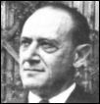](https://scottthong.files.wordpress.com/2008/08/victorvashi.gif)

VICTOR VASHI is a gentle soul who loves babies, dogs, cats and America. A graduate of the Hungarian Royal Academy of Fine Arts, he turned cartoonist for one of Budapest, Hungary’s leading newspapers, 8 Orai Ujsag.

Mr. Vashi cartooned his way through the years of Nazi and Soviet occupation of his country. He emerged from these experiences with no visible changes in his optimistic outlook or sunny personality.

The Nazis “loved” his tart cartoons, so much so that they ordered him to stay on for fifteen years. Fortunately, he managed to be engaged elsewhere during his “trial” and never served the sentence.

The Russians later became equally “fond” of his humor. He was locked in solitary confinement and was overlooked the day they cleaned out the Godollo Prison Camp, sending all able-bodied males to Siberia. This undoubtedly saved his life, but left him available for a “death march” to another concentration camp. Thus began his Communist indoctrination.

In December of 1946 Mr. Vashi managed to escape to Austria. In the process of making his way to America, he cartooned for a number of European newspapers including the Salzburger Nachten, Weiner Kurier, Hungaria of Munich, Emigrans Szabad of Paris and Praat of Amsterdam.

Mr. Vashi seriously considered writing abook, but after thinking it over decided to tell a story in cartoons, this time for the benefit of “children and diplomats.” This primer is the result.